- Circle (Khoanh tròn vào từ phù hợp với tranh)
 |  |  | 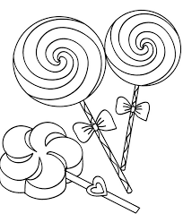 | 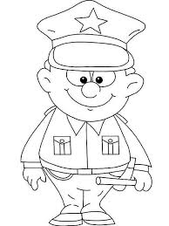
he | ice cream | doctor | cady | ploice officer
she | ike cream | dottor | candy | police officer

- Match and write (Nối và viết vào đúng vị trí)
- It’s raining a. chips. ____________________
- I want b. pillow. ____________________
- I’m c. I’m wet. It’s raining. I’m wet.
- That’s my d. Be quiet! ____________________
- Shh! e. hungry. ____________________

- Reorder the words (Sắp xếp lại câu hoàn chỉnh)
- blanket. / That’s / my
That’s my blanket.
- It’s/ hot. / sunny / I’m
_____________________________________________
- noodles. / Have / some
_____________________________________________
- a / She’s / doctor.
_____________________________________________
- Sue. / No, / today. / Not
_____________________________________________

- Complete (Hoàn thành câu bằng từ vựng cho sẵn)
Green officer He’s Stop Slow
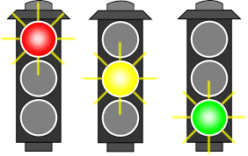
Red light! Stop!
Yellow light! ___________!
______________light! Go!
______ a police_______________

Good luck!

