UNIT 5: SHOPPING
- Listen and number
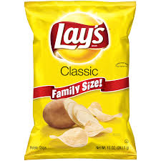  ……………….. | ………………
………………. | 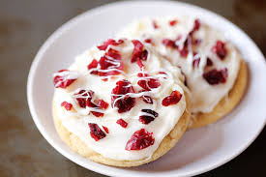  ………………

- Reorder the words in the sentences
- want / I/ candy.
………………………………………………………………………….
- No, / Not /Sue. /today.
………………………………………………………………………….
- cream / I / ice./ want
…………………………………………………………………………
- I/ chips./ want
…………………………………………………………………………

- Choose the best correct word
- A. cankdy B. candy C. kandy
- A. Sue B. Su C. Seu
- A. ice crea B. ice craem C. ice cream
- A. chips B. ckips C. hips

- Write
…………………...... | …………………… | ………………….. | …………………………

- Find out the mistakes and rewrite
- I wants cady.
……………………………………………………………………
- Not, Benny. Not today.
……………………………………………………………………

