Nội dung ôn tập tiếng Anh lớp 5 –trong thời gian nghỉ covid-19 .
PHẦN 1: Unit 4: We’re having fun at the beach .
1, Từ vựng

Beach /bi:t∫/

Sail /seil/

Surf /sɜ:f/

Kayak /'kaiæk/

Winsurf /'windsɜ:f/

Snorkel/'snɔ:kl/

Waterski
2, Mẫu câu :
Thìhiệntạitiếpdiễncóthểhiểuđơngiảnlàthìdiễntảmộthànhđông, sựvật, sựviệcđangdiễn ra tạithờiđiểmnói hay sẽdiễn ra tạimộtthờiđiểmxácđịnh, cóchuẩnbịtrướctrongtươnglaigần.
Trongthìhiệntạitiếpdiễnthườngcónhữngtrạngtừsauxuấthiện: Now, at the present, at the moment, at this time, Look! Listen!, Be careful!. Hurry up!
1, THỂ XÁC ĐỊNH
-Thìhiệntạitiếpdiễndiễntảmộthànhđộngđangdiễn ra tạithờiđiểmnói

- I’m reading book now
S + tobe + V(ing)

2, THỂ PHỦ ĐỊNH
S + tobe not + V(ing)

3, THỂ NGHI VẤN

Tobe + S + V(ing) ?

- I’m swimming  - He’s surfing | - I’m not swimming.  - He’s not surfing | Are you swimming?  - Is he surfing ?
THE EXERCISE
0. I am not drinking (not drink) beer; it’s only tea.
1. My mother __________________ (buy) some food at the grocery store.
2. Luke __________________ (not study) Japanese in the library. He’s at home with his friends.
3. __________________ (she, run) down the street?
4. My cat __________________ (eat) now.
5. What __________________ (you, wait) for?
6. Her students __________________ (not try) hard enough in the competition.
7. All of Andy’s friends __________________ (have) fun at the party right now.
8. My neighbours __________________ (travel) around Europe now.
9. The little girl __________________ (drink) milk.
10. Listen! Our teacher __________________ (speak).

UNIT 5 : A FUNNY MONKEY

1, words
penguin/'peηgwin/  zebra/'ze:brə/ /'zi:brə/  monkey/'mʌŋki/  kangaroo/kæηgə'ru:/  camel/'kæml/  lizard/'lizəd/  crocodile /'krɒkədail/ | chimcánhcụt  ngựavằn  con khỉ  húnhảy, con can-gu-ru  lạcđà  con thằnlằn  cásấu
2, structure
Yes/ No question
1, Are you reading?
Yes, I am /No, I am not .
2, Is the monkey eating the sandwich ?
Yes, it is ./ No, it isn’t .
3, Are they playing game?
Yes, they are. / No , they aren’t
THE EXERCISE

3 Underline the correct words.
/5
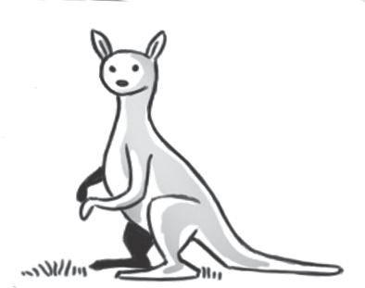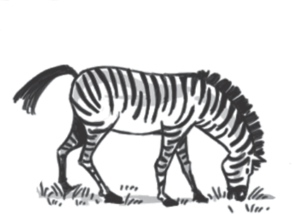Is thezebraeating? Is thekangaroo
2
1
Yes,itis/it’s/it’re. jumping?

No, itaren’t/itnot/

it isn’t.

Arethepenguins flying?
Are the lizardssleeping? Yes,theyare/they’re/
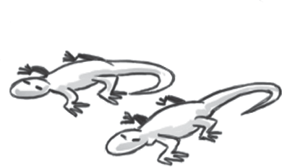No,theyisn’t/they they’s. aren’t /they no.
4

Is the crocodile eating ?
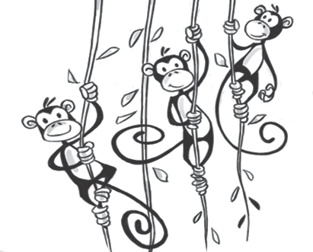Yes it is ./ No, it isn’t.
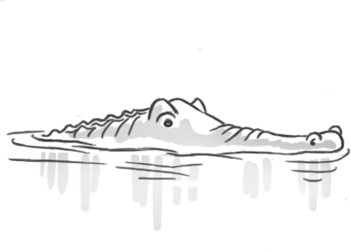
5

Are the monkeys singing ?
Yes, they are.
No, they aren’t .

0. Harry ______ books from the library.
A. borrows B. is borrowing C. are borrowing
1. My grandfather ______ stamps.
A. is collecting B. collectingC.collects
2. She ______ her friends at a bar right now.
A. waiting B. is waiting C. waits
3. Nguyen Nhat Anh is a writer. He ______ a short story about a dragon.
A. is writing B. writes C. are writing
4. I never ______ home late.
A. come B. is coming C. am coming
5. My boss ______ high heels to work.
A. doesn’t wear B. aren’t wearing C. don’t wear
6. She usually ______ much.
A. doesn’t talk B. don’t talk C. isn’t talking
7. This spaghetti ______ awful.
A. tastes B. is tasting C. taste
8. I ______ he is a good man.
A. thinks B. think C. am thinking
9. As the ceremony ______ at 7∶30 a.m., we have to be there early.
A. is starting B. start C. starts
10. Kate ______ a cup of coffee every morning.
A. is drinking B. drinks C. drink

I.THÌ HIỆN TẠI ĐƠN ( ĐỘNG TỪ TOBE)

1, Thểkhẳngđịnh :
S (Chủngữ ) +am / is/ are + ....

I am
He/ she / It/ Chủngữsốít + is
You/ We/ They / Chủngữsốnhiều + are
*Thểphủđịnh :

S (Chủngữ ) +am / is/ are + not +....

2, Thểnghivấn :
Am/ Is/ Are + S + .... ?

EX :
Thểkhẳngđịnh : He is an engineer.
Thểphủđịnh : He is not an engineer
Thểnghivấn : Is he an engineer ?
Ngoài ra cònmộtsốcáccấutrúcquantrọngkháccủađộngtừtobe ở hiệntạiđơnnhưsau :
- Wh-words (từđểhỏi )+ tobe (am/is/ are ) + S ?
EX : Who is she ?
What is your name ?
-Đạitừchỉđịnh + tobe (am/ is/ are ) + ...
This/ That/ There/ Here + is
These/ Those/ Here/ There + are
EX : This is my book
Those are pencil sharpeners
There are four people in my family.
Here is my pen.
IV.Dạngviếttắtcủađộngtừtobe ở hiệntạiđơn
am = 'm
am not = 'm not
is = 's
is not = isn't
are = 're
are not = aren't
EX : She isn't a teacher.
We aren't students.
EXERCISES
• BÀI TẬP CHIA ĐỘNG TỪ TO BE
I/ Thêm am, is, hoặc are vàonhữngcâusauđây:
1. Hello, I _________ Mai. 2. _________ you a student?
3. This _________ my mother. 4. It _________ a book.
5. That _________ an eraser. 6. How old _________ you?
7. They _________ rulers. 8. What _________ your name?
9. Her name _________ Nga. 10.These books _________ red.
11. How _________ Lan? 12.She _________ a nurse.
13.Ba _________ an engineer. 14.Nam and Bao _________ students.
15.We _________ doctors. 16.My father _________ a teacher.
17.My mother _________ a nurse. 18._________ your father a doctor?
19._________ they your pens? 20._________ it her desk?
21.This _________ Thu. She _________ a student.
22.We _________ in the yard. 23.Who _________ they?
24.What _________ those? 25.My father and I _________ teachers.
26.I _________ Lan. I _________ a student. My brother and sister
_________ teachers. My brother _________ twenty-four years old. My sister _________ twenty-one. There_________ four people in my family.
II/ Thêm am not, aren’t, isn’t vàonhữngcâusau:
1. This _________ my pen. 2. Those _________ clocks.
3. They _________ windows. 4. It _________ a pencil.
5. My father _________ a doctor. He is a teacher.6. This ruler _________ long. It is short. 7. Those schools _________ big. They are small.
8. I _________ a nurse. 9. You _________ engineers. 10.Ba and Bao _________ here.
III/ Chia độngtừ TO BE saochophùhợpvớichủtừ:
1. What (be) _________ your name? 2. My name (be) _________ Nhi.
3. This (be) _________ a board. 4. I (be) _________ eleven.
5. _________ Lan (be) twelve? 6. His pens (be) _________ there
7. _________ you and Nam (be) students? 8. _________ this (be) your ruler?
9. That (be not) _________ a desk. That (be) _________ a table.
10.Thu and Lan (be) _________ good girls. 11. I (be) _________ fine, thanks.
12.These _________ erasers. 13.There _________ a table.
14.What _________ it? 15._________ Mr Nam (be) a teacher?
16.This (be) _________ my mother. She (be) _________ a nurse. 7. There (be) _________ five people in my family.
18. Her name (be) _________ Linh. 19.It (be) _________ a door.
20.They (be) _________ doctors. 21.Which grade _________ you (be) in? 22.Which class _________ he (be) in? 23.Phong’s school (be) _________ small.
24.Thu’s school (be) _________ big. 25.My school (be) _________ big, too.

II. Thìhiệntạiđơn ̣̣( To do)
Thìhiệntạiđơnđượcsửdụngvôcùngnhiềutrongcuộcsốnghàngngàybởivìlẽnódùngđểdiễntảmộtthóiquen hay nhữngviệcthườngxuyênxảy ra ở hiệntại: sựthật ,thóiquen , quyluật , chânlý...

1,Thểxácđịnh :
S + V (Vs, V es) + O

EX: I usually wake up at 6 o’clock
• Quytắc 1:
Cácđộngtừcótậncùngbằng o, s(s), x, sh, ch, ta phảithêmđuôi ES chođộngtừ.
Example:
Go – goes ( đi)
Finish – finishes ( kếtthúc)
Do – does ( làm)
Teach – teaches ( dạy)
Push – pushes ( đẩy)
• Quytắc 2:
Cácđộngtừkếtthúcbằng y vàtrước y làmộtphụâm, ta biến y thànhirồithêm ES
Example:
Fly – flies ( Bay )
Study – studies ( học )
Cry – cries ( Khóc)
• My baby cries when waking up.
( contôithườngkhóclúcnóvừathứcdậy)
• Quytắc 3:
Vớicácđộngtừcònlại, ta chỉviệcthêm S vàosauđộngtừ.
Put – puts ( đặt, để)
Write – writes
Say – says ( Nói)
Ask – asks ( hỏi)
Buy – buys ( mua)
Come – comes ( tới)
Drink – drinks ( uống)
• Jay writes diary every evening.
Cáchphátâmđuôi S và ES
A. Quytắc 1:
• /s/
Vớinhữngđộngtừcótậncùnglà p, t, gh, f, k, đuôi S/ES củađộngtừđượcđọclà
Example:
• Puts -> /puts/
• Stop -> /stɒps/
A. Quytắc 2:
/iz/:
Vớinhữngđộngtừcótậncùnglà s, sh, ch, z, ge, che, đuôi S/ES củađộngtừđượcđọclà
Example:
• Finishes -> /ˈfɪnɪʃiz/
• Pushes -> /pʊʃiz/
B. Quytắc 3:
• /z/
Vớinhữngđộngtừcònlại, đuôi S/ES củađộngtừđượcđọclà /z/
Example:
• Cuts -> /kʌtz/
• Makes -> /meɪkz/

2, ,Thểphủđịnh :

S +do/does + not + V ( nguyênmẫu )

• Sửdụngtrợđộngtừ do vớichủngữlà I, you, we, they, danhtừđếmđượcsốnhi
- Do you like lemon juice? ( Bạncóthíchnướcchanhkhông?)
- Do Jim and Jay often come here?

• Sửdụngtrợđộngtừ does vớichủngữlà he, she, it, danhtừđếmđượcsốít, danhtừkhôngđếmđược.
• Does Mary learn English?( Mary họctiếng Anh à)
• Does your pet eat animal food ?
3. Thểnghivấn (?)

• Do/does + S + V + O?
• Wh + do/does + S + V + O ?

Ghinhớ :Khimượntrợđộngtừđộngtừchínhluôngiữ ở dạngnguyênmâũ
Exercise 1
1: I _______ my homework every evening. (do)
2: She ________ to church every Sunday.(go)
3: My friend often _________ football. (play)
4: John and Martin always ________ to class late(come)
5: My parents ______ me every weekend.(visit)
6: My dad ________ a book before going to bed.(read)
7: My team always _______. (win)
8: I ______ by myself. (cook)
9: She always _____ her work at 9 pm (finish)
10: Jim ________ English very well. ( Jimhọctiếng Anh rấtgiỏi)
Exercise 2

1. You (be) _____________ free next Saturday morning? – No, I (visit) _____________ my grand mother.
2. Trang (not be) _________ in her room at the moment. She (cook) ___________ in the kitchen.
3. Would you like (have) ______________ breakfast with eggs?
4. Lien (not go ) ______________ to the movie theater tomorrow. She (stay) ______________ at home.
5. The train for Hanoi (leave)______________ at 7.30 tonight.
6. I (know) ______________ you (be)______________ busy now.
7.Lan (not have) ______________ many new friends in her new school.
8.hung (come) ______________ from Vinh, but he (stay) ______________ with his relatives now.
9.We (not drive) ______________ to work every day. We (go) ______________ by bus.
10.Who (talk) ______________ on the phone, Nam.
11.They (often build) ______________ hotels, but this year they (build) ______________ hospitals.
12. Hurry up! The bus (come) ______________.
13. My mother is saving money because they (buy) ______________ a new house next year.
14. We’ll go out when the rain (stop) ______________
15.Mr. Thanh (be) ______________ a doctor. He (work) ______________ in a hospital in the city center. Everyday he (catch) ______________ the bus to work.
16.We (not go) ______________ camping next week.. We (visit) ______________ the museum.
17. I like (join) ______________ your club.
18. Hurry up ! We (wait ) _________ for you. If you (be) ________ slow, we (miss) __________ the bus.
19. My mother is saving money because they ( buy) ______________ a new house next year.
20. She is preparing her trip now. She (visit) ______________ her friends tonight.
21.What____________ your father usually ____________ (do) in the evenings ?
22. He usually ____________ (watch)TV. He (not talk) ____________ to her at present.
23. He____________ (be) out at the moment but he____________ (be) back at about seven o’clock.
24. I can ____________ (see) the children. They____________ (play) in the yard.
25. Would you like____________ (listen) to music ?
26. No, thanks. I like____________ (read) books.
27. Don’t worry. I (give) ____________ him your message when I (see) ____________ him.
28. Look! Jane (play) ____________ the guitar. this afternoon she (play) ____________ table tennis.
29.When you (go) ____________ into the office, Mr. John (sit) ____________ at the front desk.
30.We (wait) ____________ for you when you (get) ____________ back tomorrow.
31.His brother (finish) ____________ high school 6 years ago.
32.The farmers in my village often (begin) _________their work very early in the morning.
33.Today, the scientists in the world (do) _________ research on Aids.
34.We (leave) _________for Ha Noi on the earliest plane tomorrow.
35.When we were kids, we (not understand) _________ the importance of choosing a career.
36.Last night we (not stay) ______________ at home, but we (go) ______________ to the cinema.
37.Hoa (keep) _____________ her teeth very careful. She (brush) _____________ her teeth twice a day.
38.I’d like (go) ______________ fishing. I (go) _______ fishing when I (have) _______free time.
39._______you (do) _______ your homework yesterday?
40.When _______you ( buy ) _______this comic ?- I (buy) it two days ago.
41. When I was a child, I (not like ) ______________ eating vegetables. I only ( eat ) ___________. meat and fish. Now I ( know ) _______ that vegetables are good for health so I often ( have ) _______ them for meals.
42.Long is a hard working student, now he ( read) _______ books in the library. He (go) _______there three times a week. Last week he ( go) _______there only once because he (have) _______a flu.
TRONG QUÁ TRÌNH LÀM BÀI , CÓ GÌ KHONG HIỂU GỌI CHO GV DẠY TIẾNG ANH LỚP MÌNH NHÉ CÁC EM. CHÚC CÁC EM LÀM BÀI TỐT!

