Exercise 1 : Match

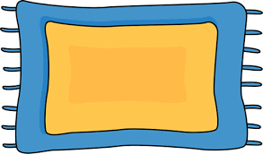  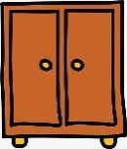  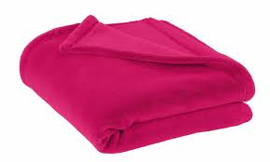

cabinet

blanket

rug

pillow

shelf

Exercise 2 : Answer the questions.

  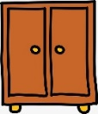

What is this ? What is this ? What is this ?

It is a rug. ____________________ . _____________________.

  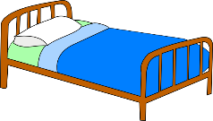

What is this ? What is this ? What is this ?

_____________________. _____________________. _____________________.

Exercise 3 : Look and write : **Yes , it is** or **No , it isn’t**.

|  |  |
| --- | --- |
|  |  |
| 1.Is it a blanket ?  *..................................* | 2. Is it a cabinet ?  *.............................................* |
|  |  |
| 3. Is it a rug ?  *..........................................* | 4. Is it a shelf ?  *.......................................* |
|  | Káº¿t quáº£ hÃ¬nh áº£nh cho bed clipart |
| 5. Is it a pillow ?  *......................................* | 6.Is it a bed ?  *..........................................* |

Exercise 4 : Look at the picture and write **:**

|  |
| --- |
| in on next to under |

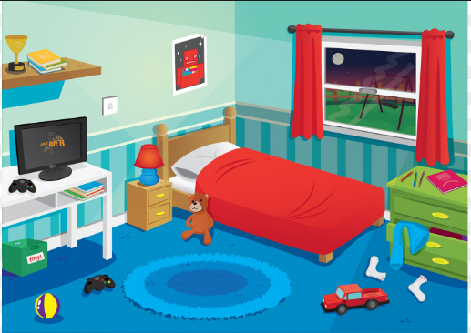

|  |  |
| --- | --- |
| a. There is a teddy bear __________ the bed. | b. There is a pillow ______________the bed. |
| c. There is a picture _____________the wall. | d. There are books _____________the shelf. |
| e. There are pens _____________the cabinet. | f. There is a rug _____________ the floor. |
| g. There is a blanket _____________the bed. | h. There is a bed ____________ the room. |
| i . There is a lamp ___________the cupboard. | j. There is a computer ____________ the table. |

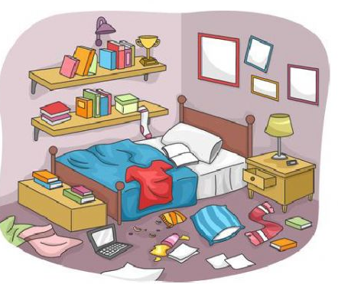Exercise 5 : Complete the **there is** / **there are**

_____________ a t- shirt on the bed.

_____________ two books on the floor.

_____________ a scarf on the floor.

_____________ four pictures on the wall.

_____________ many books on the shelves.

_____________ a book on the bed.

_____________ a laptop on the floor.

_____________ some papers on the floor.

Exercise 6 : Read and circle.

1. There **is /are** ten books on the shelf.
2. There **is /are** a doll on the bed.
3. There **is /are** a ball under the chair.
4. There **is /are** a teddy bear on the bed.
5. There **is /are** a pencil case in the bag.
6. There **is /are** two balls under the table.
7. There **is /are** two pillows on the bed.
8. There **is /are** a clock on the table.
9. There **is /are** a doll on the rug.
10. There **is /are** two robots in the box.

Exercise 7 : Read the text and the sentences . Tick (🗹 ) or cross (🗷)

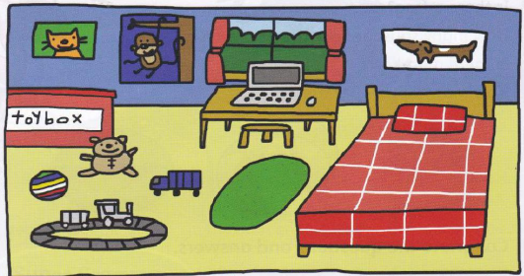

***I live in a big house. It isn’t old, it’s new. There are four bedrooms, a kitchen, a dining room, a living room and a hall. My bedroom is my favorite room. It’s blue. There are posters of animals and I have a green rug . There is a desk in my bedroom and I have a computer . There isn’t a TV . My toys are in my bedroom . I play with my toys at the weekend.***

|  |  |
| --- | --- |
| a. The house is small. | 🗷 |
| b. There are five bedrooms. |  |
| c. There is a rug in the bedroom. |  |
| d. There isn’t a computer. |  |
| e. There’s a TV in the bedroom. |  |
| f. There are toys in the bedroom. |  |
| g. There is a ball in the bedroom. |  |
| h. There are two pillows on the bed. |  |
| i. There is a toy box in the bedroom. |  |

Exercise 8. Complete the sentence.

|  |  |
| --- | --- |
| dining room - kitchen - bathroom -  ~~bedroom~~  - hall - lounge | |
| 1. There is a bed in the ____________________. 2. The ___________________ is upstairs . 3. There is a boy in the ____________________. 4. There is a sofa in the ____________________. 5. The stairs are in in the ____________________. 6. The ____________________ is downstairs. |  | |

Exercise 9. Look and fill in with **There is, There are, There isn’t ,There aren’t**

|  |  |
| --- | --- |
|  | 1. ___________________ a mirror. 2. ____________________ any rollerblades. 3. ________________________ a TV set. 4. ________________________ some books. 5. ________________________ a paper bin. 6. ________________________ three boxes. 7. ________________________ any curtains. 8. ________________________ a ball 9. ________________________ a schoolbag.   10. ______________________ an armchair.  11. _______________________ some toys.  12. _______________________ a bed.  13. _______________________ two lamps.  14. _____________________ any rubbish. |

Exercise 10. Describe the picture using **There Is** or **There Are**

|  |  |
| --- | --- |
| thereis.jpg | 1. _______________________________________ 2. _______________________________________ 3. _______________________________________ 4. _______________________________________ 5. _______________________________________ 6. _______________________________________ 7. _______________________________________ |

Exercise 11. Complete the sentences using **There is** or **There are:**

This is my flat. _______________ two bedrooms and a living-room. ______________also a kitchen and ________________ a bathroom. In the living-room ________________six chairs and a sofa. __________________ a big table too. Besides _______________ a clock on the wall, ________________ a lamp and ________________a shelf full of books.

Exercise 12. Look , read and choose  or

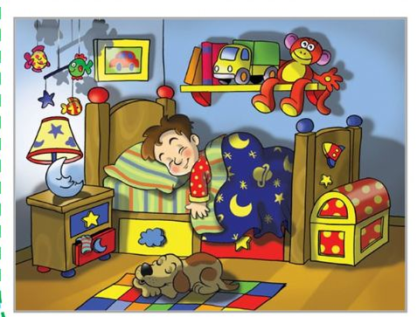

|  |  |  |
| --- | --- | --- |
| **Sentences** |  |  |
| 1. The boy is reading a book. |  |  |
| 1. There is a monkey on the bed. |  |  |
| 1. The boy is sleeping. |  |  |
| 1. There is a monkey on the shelf. |  |  |
| 1. The dog is eating pizza |  |  |
| 1. The moon is angry. |  |  |
| 1. The dog is sleepy. |  |  |
| 1. There are five fish in the room. |  |  |

Exercise 13. Make questions

a***) How many apples are there on the table ?***

There are three apples on the table.

b) *.................................................................................................*

There is a cat under the chair.

c) *.................................................................................................*

There are ten books on the shelf.

d) *.................................................................................................*

There is a pillow on the bed.

e) *.................................................................................................*

There are two dolls on the rug.

f) *.................................................................................................*

There are four books in the bag.

g ) *.................................................................................................*

There are two pens in the pencil case.

h ) *.................................................................................................*

There is a pencil on the table.

i ) *.................................................................................................*

There are two bags next to the table.

j) *.................................................................................................*

There is a pencil case on the table .

k) *.................................................................................................*

There are two rulers on the table.

l) *.................................................................................................*

There are two rabbits behind the tree.

m ) *.................................................................................................*

There is a bed in the bedroom.

n ) *.................................................................................................*

There is a robot on the bed.